Texas Wranglers

Established 1979

The University of Texas at Austin



Texas Wranglers

Spring 2016 Maverick Application

Letter from Ben Whitaker, Head Recruitment Chair, 2016

Dear Potential Applicant,

Since 1979, Texas Wranglers have served The University of Texas at Austin as the official spirit group of the men’s basketball team. Recently the Texas Wranglers have been recognized with the 2015 Tower Awards as an “Outstanding Student Organization”. Being a Wrangler is not just a title, it is a lifestyle dedicated to Leadership, Scholarship, and Athletic Ability. Our founding father, Kevin J. Lilly, established the Texas Wranglers with the intent to provide young men the opportunity to not only better themselves, but also the community around them.

Today, Texas Wranglers remain a premier social and service organization by upholding a high standard of excellence. Texas Wranglers wear a Cowboy hat and our signature Howdy shirt on game days to identify us as a distinguished spirit group. Each year, Texas Wranglers raise approximately $30,000.00 for our main philanthropy, Easter Seals of Central Texas, through our [City Wide Hold Up Event](http://citywideholdup.org). Texas Wranglers also compete in many intramural sports. With athletics being an important pillar to us, we strive for nothing less than championships. We are currently the winners of the 2015 University-Wide Flag Football Championship. I can honestly say that Texas Wranglers has made my time here at Texas something I will never forget. The organization has not only introduced me to my best friends and roommates, but Wranglers have also taught me valuable lessons in life. Joining Wranglers will be something that you will be immensely proud of and will be a decision that you will never regret.

We strongly encourage all interested applicants to attend all of the events on the recruitment schedule as listed on the following pages. Our website [texaswranglers.org](http://www.texaswranglers.org/#!home/mainPage) and our [Facebook page](https://www.facebook.com/groups/1644449475807669/) are great resources for you to learn more about Texas Wranglers. Before you begin the application process, please read the information very carefully and be sure to follow all instructions.

I will be available to answer any questions you may have throughout the application process. My contact information and my co-recruitment chair’s contact information are listed below. Please do not hesitate to contact Gavin or me if you have any questions or concerns about the recruitment process, the application, or what membership in Texas Wranglers entails. Again, we thank you for expressing interest in becoming a Texas Wrangler. We wish you the best of luck throughout the application process.

Very Respectfully,

Ben Whitaker

**Selection Chair Contact Information**

**Head Recruitment Chair**

Ben Whitaker

903-517-5440

**Co-Recruitment Chairs**

Ryan Wagner

979-224-8238

Brian Vasquez

210-387-9191

**Email**

[wranglersrecruitment@gmail.com](mailto:wranglersrecruitment@gmail.com)

**Instructions**: Fill out this application, **save file as “lastname, firstname.doc”** (.docx may also be used) and email to [**wranglersrecruitment@gmail.com**](mailto:wranglersrecruitment@gmail.com) with only your name (lastname, firstname) in the email subject line and no text in the body. We accept only electronic applications. **Applications must be submitted by 11:59 p.m. on Friday, September 9th, 2016.**

Please respond to the following questions thoughtfully and use as much space as you find necessary. The Texas Wranglers have no tolerance for acts of dishonesty or deception. Applications are examined for accuracy and truthfulness, and candidates found to falsify or misrepresent any part of this application will be banned from the Texas Wrangler recruitment process indefinitely.

Applicants are evaluated based on their overall application. We go through two rounds of selection in order to ensure that only those who excel in scholarship, leadership, and athletic ability are given the opportunity to become a Texas Maverick, and ultimately, a Texas Wrangler. The first round is decided by our selection committee and will be based upon your application as well as any interactions that you have had with our membership. You will be contacted by September 11th, 2016 if you are selected to continue to the second round of the recruitment process. If selected, we will schedule you for an interview. The second and final selection will be decided by our general membership and will be based on a cumulative evaluation including your interview.

Please insert into this document a photograph of yourself. *NOTE:* *Your photograph will NOT be used as a basis for acceptance or dismissal. Its purpose is to make your application more personal and to allow Wranglers to identify you more easily.*

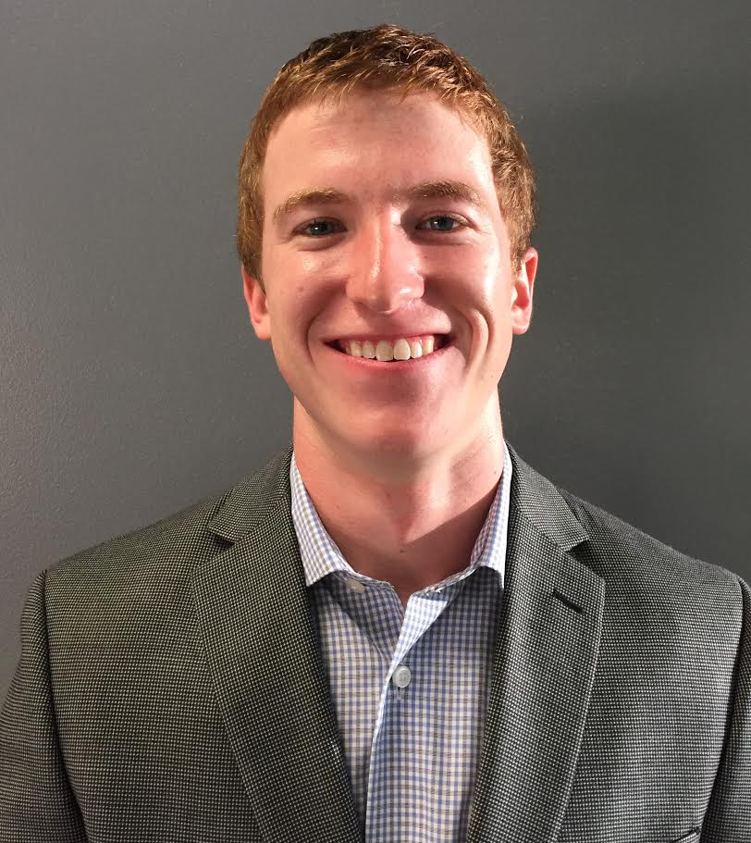

**General Info (All fields are required)**

|  |  |
| --- | --- |
| **Legal Name:** | Avery Charles Pawelek |
| **Preferred Name:** | Avery |
| **UT EID:** | acp2478 |
| **Local Address:** | 2021 Guadalupe St.  Unit 2207  Austin, TX  78705 |
| **Permanent Address:** | PO Box 1583  George West, TX  78022 |
| **Email:** | averypawelek4@gmail.com |
| **Phone:** | 830 – 299 – 0218 |
| **Hometown:** | George West, Texas |
| **Wrangler References:** | none |
| **How you heard about Wranglers:** | tabling |

**Academics**

|  |  |
| --- | --- |
| **High School (HS):** | George West High School |
| **HS GPA and Scale (ex. 3.8/4.0):** | 103.7/100.0 |
| **HS Class Rank (ex. 121/800)** | 2/78 |
| **College GPA (if applicable):** | 4.0000 |
| **Major:** | Physics and Mathematics |
| **Classification by Year:** | Junior |
| **Colleges Prior to UT (if any):** |  |
| **Semesters Completed at UT (#):** | 4 |

**Athletics**

Please list the sports you participated in during high school and college (high school teams, city leagues, club teams, intramurals, etc.) as well as any athletic accomplishments you have achieved (triathlon, marathon, etc.). Also, please list the number of years you competed and any honors you may have received (team captain, varsity, letters, 1st team district, etc.). Please list as many activities that are applicable by copying and pasting the following information template. **Remove the example when complete.**

|  |  |  |  |
| --- | --- | --- | --- |
| **Sport/Event** | High School Track | **Duration** | 3 Years |
| **Honors** | 3 year letterman (freshman, sophomore, and junior years, did not participate in track senior year due to ACL tear suffered during football season), district champion in 100m dash (sophomore and junior year), regional finalist in 100m dash (sophomore and junior year), district champion in 200m dash (junior year), regional finalist in 200m dash (junior year), regional finalist in 800m relay (junior year), GWHS record holder in 100m dash (time of 10.78s) | | |
| **Sport/Event** | High School Football | **Duration** | 4 Years |
| **Honors** | 3 year varsity starter (sophomore, junior, senior years), district champion (sophomore and junior years), 1st team all-district cornerback (junior and senior year), 1st team all-district running back (senior year), team captain (senior year) | | |
| **Sport/Event** | Intramural Track Meet | **Duration** |  |
| **Honors** | 2nd place in 100m dash (freshman year of college) | | |
| **Sport/Event** | NIRCA National Intramural Track Meet | **Duration** |  |
| **Honors** | 8th place in 100m dash (sophomore year of college) | | |
| **Sport/Event** | Intramural Flag Football (sophomore year of college) | **Duration** |  |
| **Honors** | Semi-finalist in Coed A league (sophomore year of college) | | |
| **Sport/Event** | Intramural Softball (freshman year of college) | **Duration** |  |
| **Honors** |  | | |
| **Sport/Event** | Intramural Basketball (freshman and sophomore year of college) | **Duration** |  |
| **Honors** |  | | |

**Leadership and Extracurricular Activities**

Please list any organizations you were actively involved with during high school and college if applicable (religious, musical, extracurricular, academic, etc.). Please include the number of years you were involved as well as any leadership roles you took on as a member of that organization. Please list as many activities that are applicable by copying and pasting the following information template. **Remove the example when complete**.

|  |  |  |  |
| --- | --- | --- | --- |
| **Organization** | UIL Academics (high school) | **Duration** | 4 Years |
| **Leadership Role** | regional qualifier in UIL science (all 4 years), regional qualifier in UIL mathematics (junior and senior year), regional and state champion in UIL physics (junior and senior year), regional champion in UIL mathematics (senior year), state runner-up in UIL mathematics (senior year) | | |
| **Organization** | Student Government (high school) | **Duration** | 1 Year |
| **Leadership Role** | Class President (senior year), Student Council President (senior year) | | |
| **Organization** | National Honor Society | **Duration** | 2 Years |
| **Leadership Role** | Member (junior and senior year) | | |

**Community Service**

Please list any community service that you have performed within the last 2 years. Please list as many activities that apply by copying and pasting the following information template. **Remove the example when complete**.

|  |  |  |  |
| --- | --- | --- | --- |
| **Organization** | Earl Campbell’s Flavors of Austin | | |
| **Description** | Helped set up and run Earl Campbell’s Flavors of Austin event. An event which raises funds to help people with multiple sclerosis | | |
| **Length of Service** | 4 hours | **How Often** |  |

**Additional Awards and Recognitions**

Please list any other awards you may have received during high school and college. Please list as many awards/recognitions that apply.

* Distinguished College Scholar (2016) – named a distinguished scholar in 2016, meaning I am in the top 4% of my college class.
* National Merit Commended Scholar (2013)
* Academic All-State Elite Football Team (2013) – named to the Academic All-State Elite team for football, the highest academic all-state honor attainable.

**Short Answer Questions**

Please respond to the following questions. Limit each response to 250 words or less (the point is to be thoughtful and concise, not to write a full page essay).

1. **What motivates you to put forth your greatest effort?**

I do not feel as though I need motivation to put forth my greatest effort. I personally believe that giving anything less than my greatest effort to something that I do is a disgrace to the talents that I have been blessed with. That being said, if I had to pick one thing in particular that motivates me, I would say I am motivated by my desire to achieve greatness in everything that I do in life. Since I was a little boy, my parents taught me to strive to be the best. My mom, a teacher, taught me to accept nothing less than A’s in all of my classes, and my dad, a coach, taught me how to push myself physically to get the most I could from my body. My parents would only accept great effort and great results, and this has definitely rubbed off on me. Now that I am on my own in college, I expect the same great effort and results from myself. I would say that this deeply ingrained drive to be the best I can be and get better every day motivates me to give my greatest effort in all things that I do.

1. **Describe a time when you acted as a leader, describe the situation and what you did to better those around you in that role?**

My senior year of football was one of the most mentally challenging experiences of my life, and it forced me to take a leadership role and lift up the young players on the team. Going into the season, we knew it was going to be a difficult one because many good players from the team the year before graduated and a lot of young guys had to fill in those spots, and on top of that we had a very difficult schedule to face. Although we expected things would be difficult, the season was more challenging than we could have imagined. We ended the season with a 3-7 record, losing some games by over 40 points. Because we were a small school, I had to play offense, defense, and every special team. Playing every down of a football game that you are losing by 40 points is very mentally challenging. However, in this difficult time I learned how to be strong and provide energy to my teammates when we were struggling. I continued to play hard every down and ended up getting 1st team all-district honors on both sides of the ball. I set a good example for the young players on the team and pushed them to give everything they had. Although our team simply did not have the talent to be successful that year, we always played hard, and I think my leadership was in part responsible for the great effort we gave.

1. **Describe a time in your life when you made a sacrifice in the interest of someone else rather than yourself?**

A time in my life when I made a sacrifice in the interest of someone else was when I made the decision to always give to homeless people that I see on the street. During my first year and a half of college, I would get very uncomfortable around the homeless people on the Drag and would just keep walking when they would try to talk to me or ask me for money. However, last semester I made the decision that I would try my best to always carry some change on me to give to the homeless people that I ran into. After I made this choice I started to feel much better about myself, and I realized that my discomfort around the homeless was completely irrational. I realized that they are human, just like I am, and sacrificing a few dollars or a minute of my time to talk with them was very rewarding. It felt great to make someone smile and to bring some joy into their difficult lives. I feel that this decision has made me a better man, and has increased my appreciation for public service.

1. **What do you think your greatest contribution to the Texas Wranglers would be?**

I believe that my greatest contribution to the Texas Wranglers would be my determination and drive to succeed. I think that my desire to achieve great things would inspire my fellow Wranglers to be the best they can be in whatever endeavors they undertake. I have a great passion for the University of Texas and want to make it an even better place. These passions, combined with my strong academic record, leadership skills, and athletic ability, will make me a valuable member of the organization. I also believe that as an older applicant (I am currently a junior) with great academic success under my belt, I will be able to set a good example for my fellow, younger Mavericks and help them out as they get adjusted to UT.

**(Optional) Describe anything about yourself that you would like the selection committee to consider in addition to the information that you have already provided.**

If you are a returning applicant and have already applied during a previous semester, respond to the additional question.

**What goals have you accomplished or how have you demonstrated the Wrangler aspects of Leadership, Scholarship, and Athletic Ability since your last application?**

Not applicable, I am a first time applicant.